Module 2
create a table Customer and insert 5 records into it:

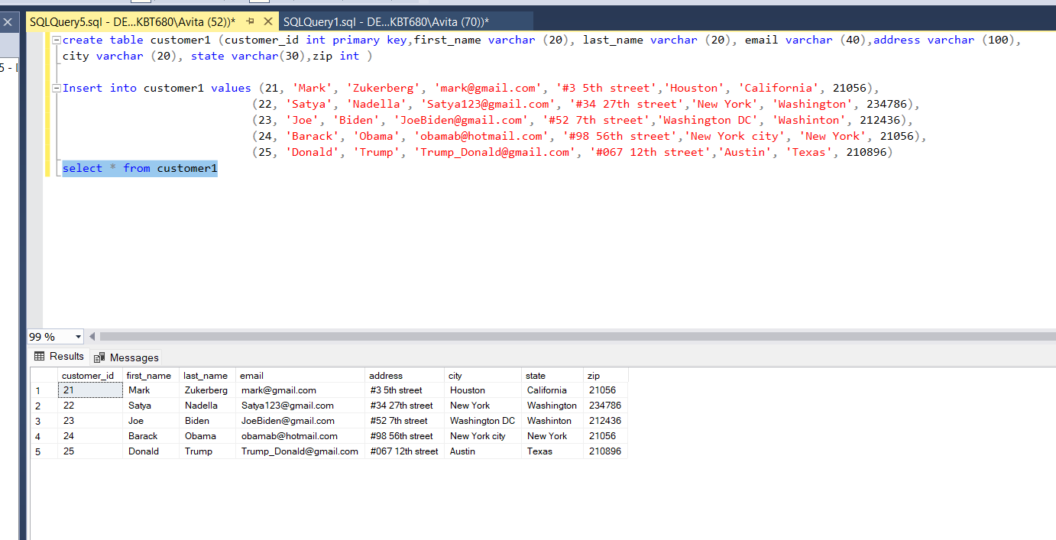

Module 2
Select only First name and last name from customer table

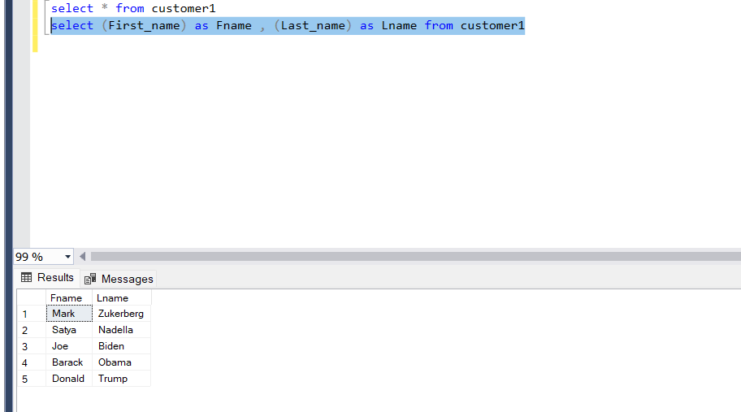

Module 2
Find the name which starts with M and city ‘Houston’

